Title: | Install an Apache Web Server and WordPress
Updated: | April 16, 2025 | Due Date: | Midnight before the next class meeting.
Purpose: | This lab is designed to gain practical skills in web hosting and Linux administration by installing an Apache web server and WordPress on a Linux system using skills attained in this course. The lab challenges students to configure and install a Linux server with Apache, MySQL, and PHP to serve web pages, and secure the MySQL database. Students will also download, install, and configure WordPress, including setting up a database and user. The lab emphasizes hands-on learning, critical thinking, and the application of technical knowledge in a real-world scenario, enabling students to deploy their own website on Linux.
Knowledge: | Installing software, configuring services, and researching requirements for a specific piece of software.
Task/Activity: | A. Install Linux  B. Setup PuTTY to Connect  C. Install Server Services  D. Download and Install WordPress  E. Reflection
Criteria for Success: | Success in this lab is marked by accurate task completion, effective analysis, documentation, and clear communication of findings. A crucial aspect involves reflecting on the purpose of the lab, linking procedures to broader concepts, and recognizing the lab's significance within the course.  Overall, success is not only measured by technical proficiency but also by critical thinking, effective communication, and a reflective summary that captures the challenges faced and insights gained throughout the lab experience.
- Install Linux
- We will need a Linux machine to build on. Create a web server in AWS with the following settings:
- Name: Apache Project
- Linux RedHat Enterprise Linux 9
- 50GB Storage
- T2.medium instance type
- Generate a new keypair named WordPress
- Setup PuTTY to Connect
- Configure PuTTY (or the SSH client of your choice). Submit a screenshot (or shots if there are multiple pages/tabs of configuration) below.
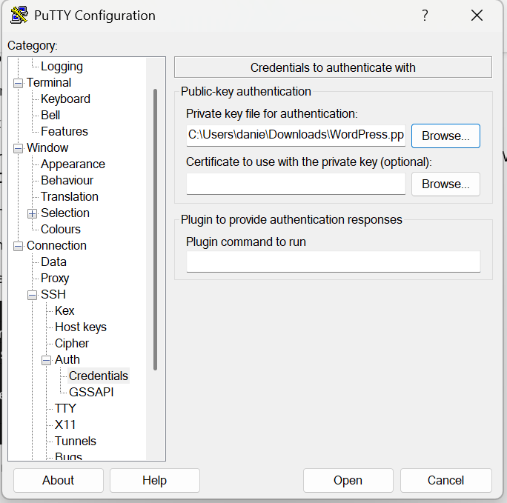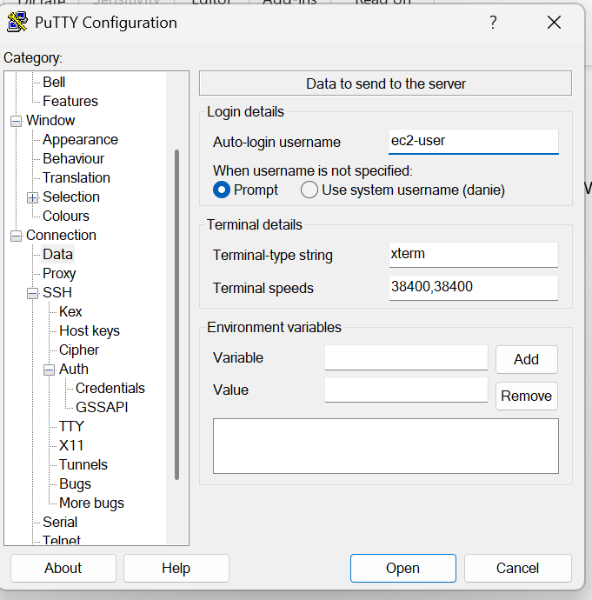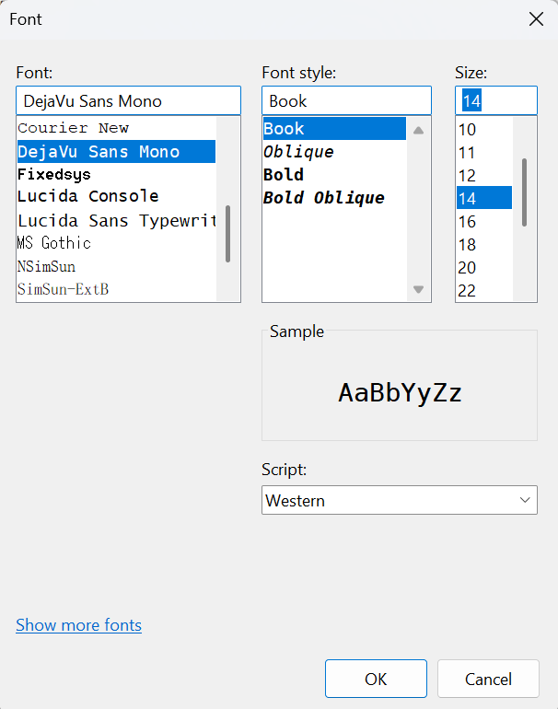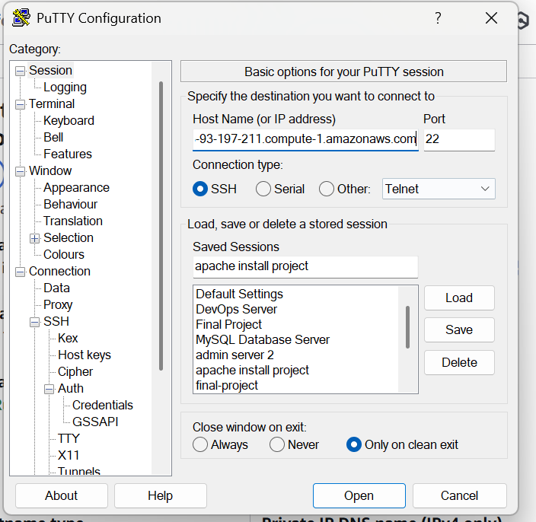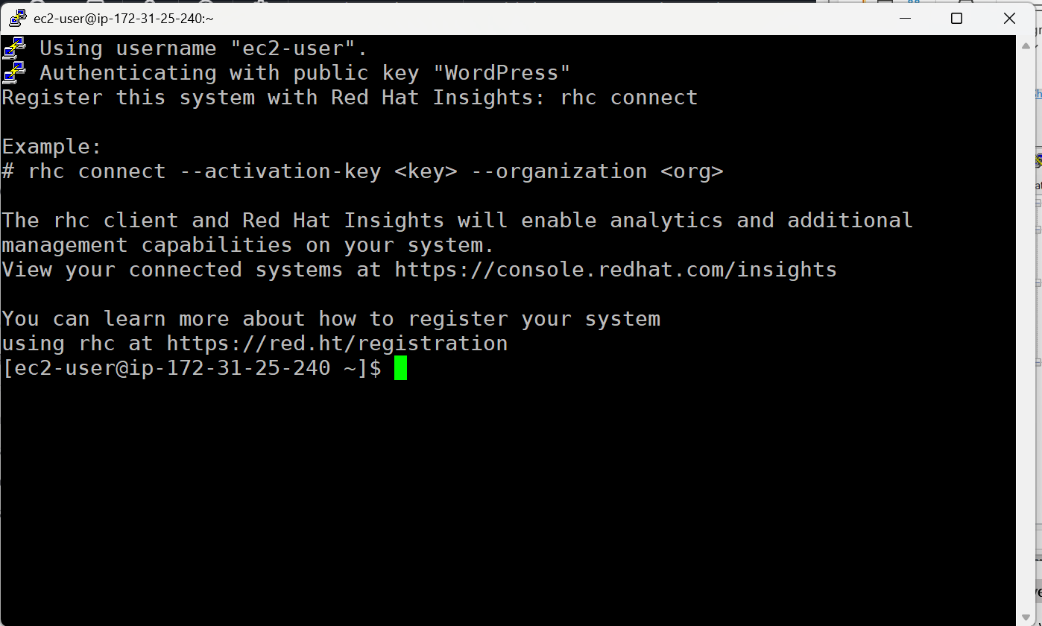
- Install Server Services
For our web server to serve pages to the internet, there are a few things that we need to install. First, we need to install the Apache web server. Apache is one of the most popular web servers on the internet, with over 30% market share.
- Research the command to install the Apache web service on your server. Install the service and document the command(s) that you ran below.
sudo su
dnf install httpd

- Make sure that the security group in AWS is configured to allow web traffic on port 80 (non-secure) and 443 (secure). Document your steps below.
We navigate back to our instance on aws and edit inbound rules 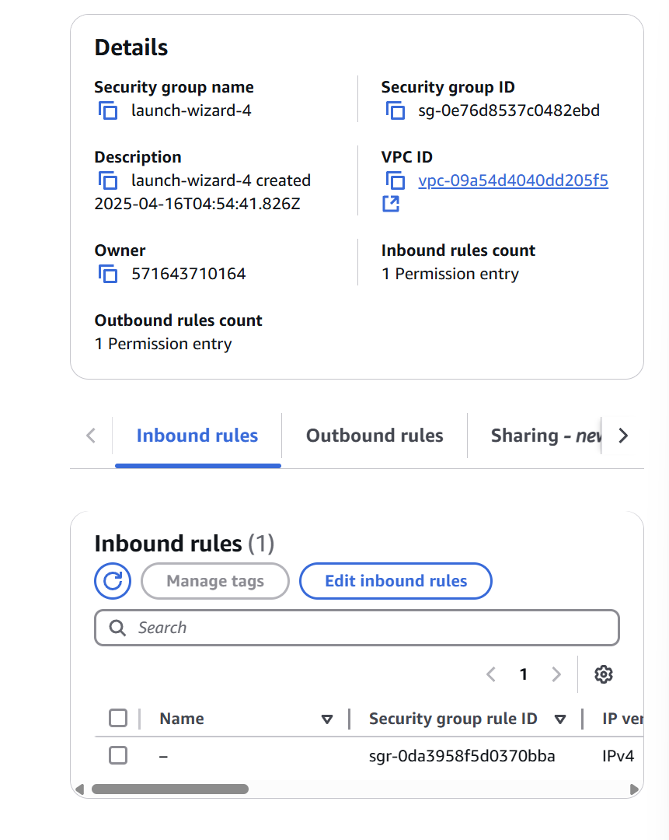
Then we want to add the new rules to allow access via pot 443 and port 80
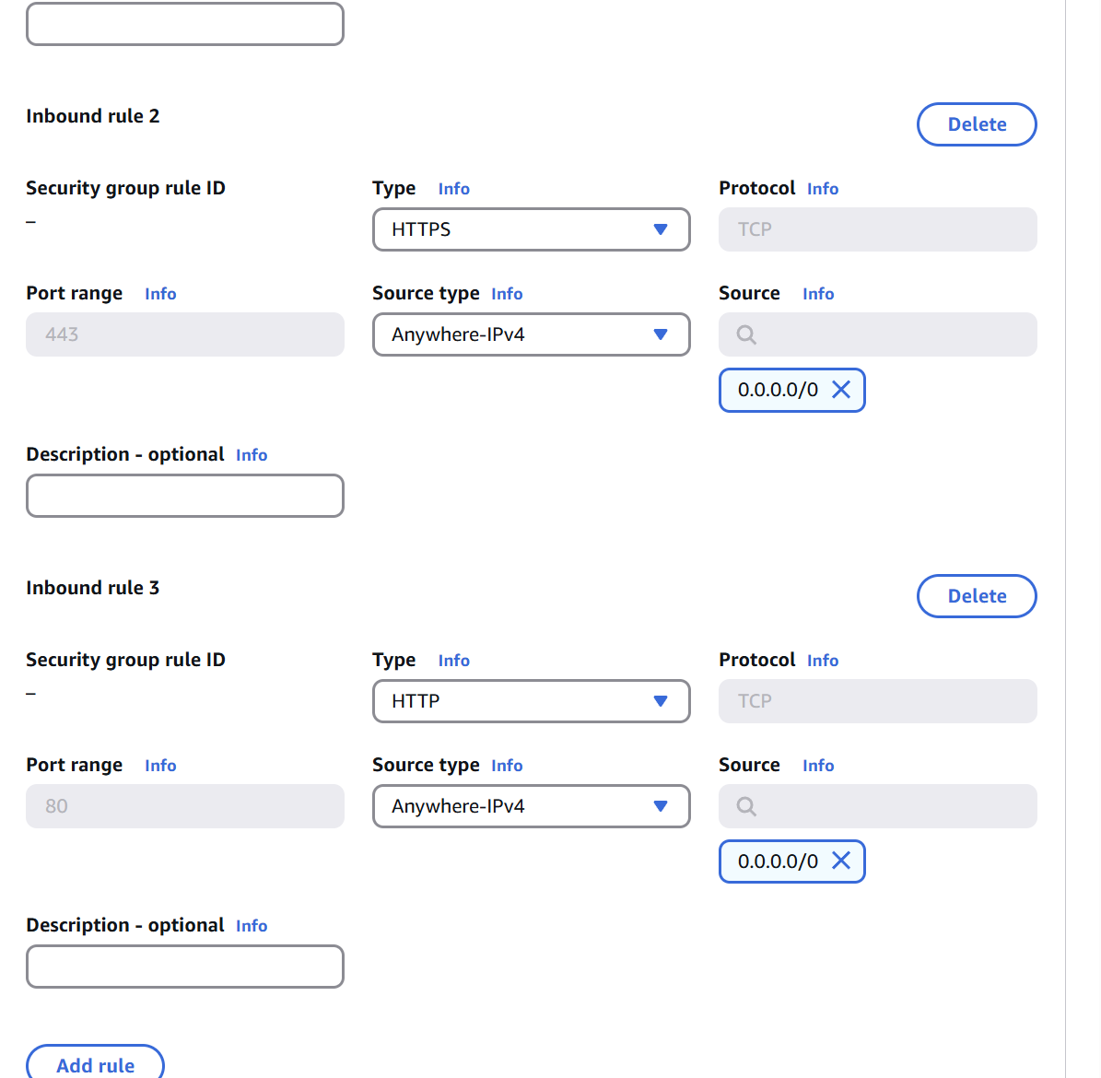
- With Apache installed, start the service, and enable it to start on boot. Document your commands below.
systemctl enable httpd
systemctl start httpd
Apache isn’t the only service that you need to install to have a functioning web server that can run applications like WordPress. We also need a database server to run the backend information for WordPress.
- Research the database system that WordPress requires and install it on your system. What is the requirement for a database?
In the research the necessary database needed to run on wordpress is MySQL.
- What command did you use to install the required database? Don’t forget to start the service and enable it to start on boot. Include those commands as well.
dnf install mysql-server
systemctl start mysqld.service
systemctl enable mysqld.service

To properly setup and configure the database, there are some additional steps needed. This will help secure the database server from being compromised.
- Run the mysql_secure_installation command and follow the prompts to secure the database system.
  - During the setup, you will be asked to set the root password. This is different from the root password for the server itself. This is the database root user password. I recommend for this lab using the same password as your system root password. In the real world, you would pick something different for security purposes.
  - Removing anonymous users is best practice. By default, there is an anonymous user that would allow anyone to connect to your database, which is a security vulnerability.
  - Removing the ability for root to login remotely is also good security practice. The root user should only be allowed to login on the same system, which prevents compromised root user credentials from working remotely. The threat actor would have to be logged in locally to make use of the database root user.
  - Removing the test database removes another possible vector for attackers, since it is installed by default on every system, it is a target.
  - Reloading the privilege tables applies the settings you made in this tool.
- WordPress needs a blank database and a username and password to utilize the database. Run the following commands to create the user “wordpress” with the password “student” and database “wordpress”.
# mysql -u root -p
Enter password: student
MariaDB [(none)]> CREATE DATABASE wordpress;
MariaDB [(none)]> CREATE USER ‘wordpress’@’localhost’ IDENTIFIED BY ‘student’;
MariaDB [(none)]> GRANT ALL PRIVILEGES ON wordpress.* TO ‘wordpress’@’localhost’; This should be all on one line
MariaDB [(none)]> FLUSH PRIVILIGES;
MariaDB [(none)]> exit;
The server is now setup to serve web pages, and use a database backend. There is still one more part of the puzzle that we will need to add before WordPress will run. Apache needs to be told how to parse PHP programming code.
- Research the version of PHP that WordPress needs (https://wordpress.org/about/requirements/), and install PHP, along with the tools that are needed for Apache to use PHP. Document the commands below.
Note: After making any changes to Apache, the service will need to be restarted.
Looking into the versions of MySQL that were installed, we have version 8.0 of MySQL, so we need WordPress version 6.8 and PHP versions 8.1-8.4.

dnf update
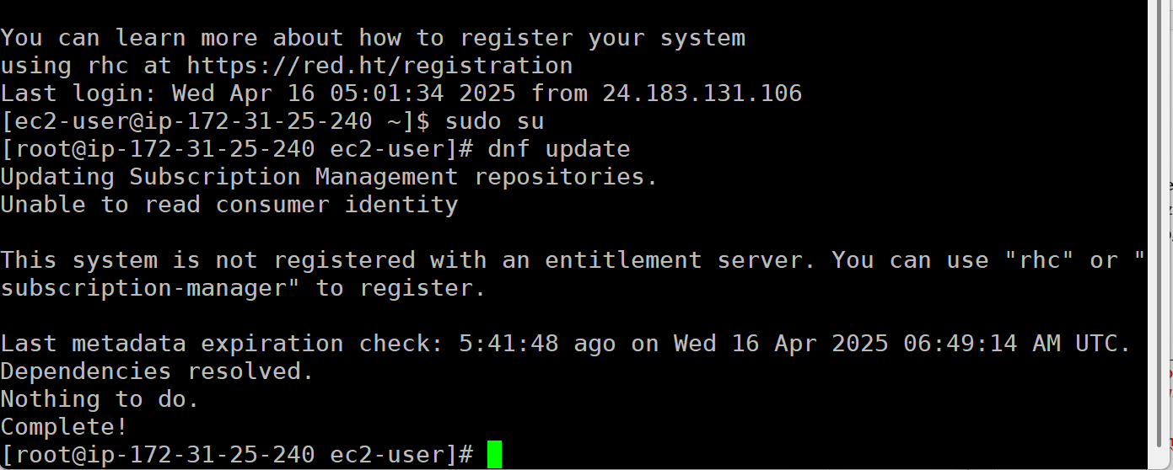

dnf install \https://dl.fedoraproject.org/pub/epel/epel-release-latest-9.noarch.rpm
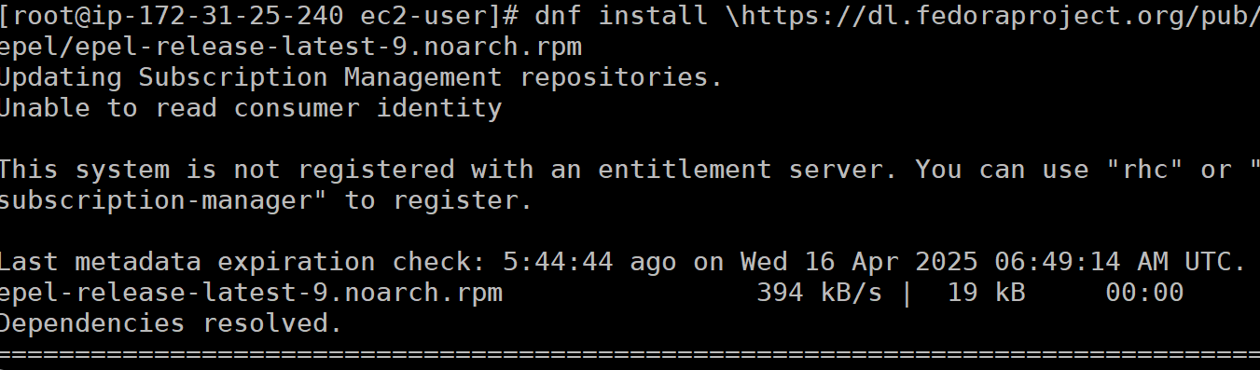
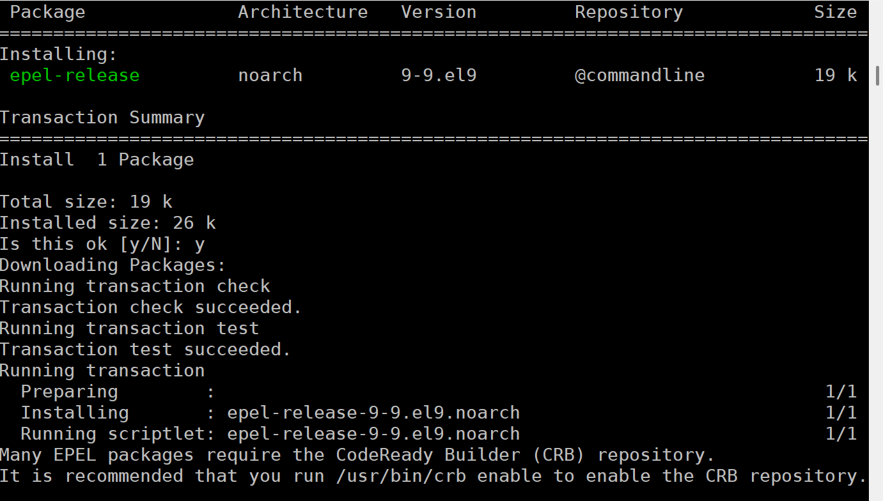

dnf install -y https://rpms.remirepo.net/enterprise/remi-release-9.rpm
dnf module reset php
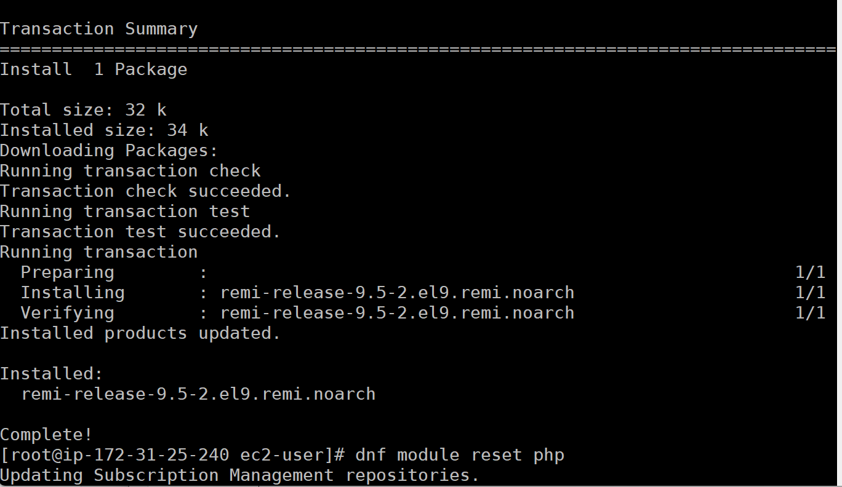

dnf module enable php:remi-8.1
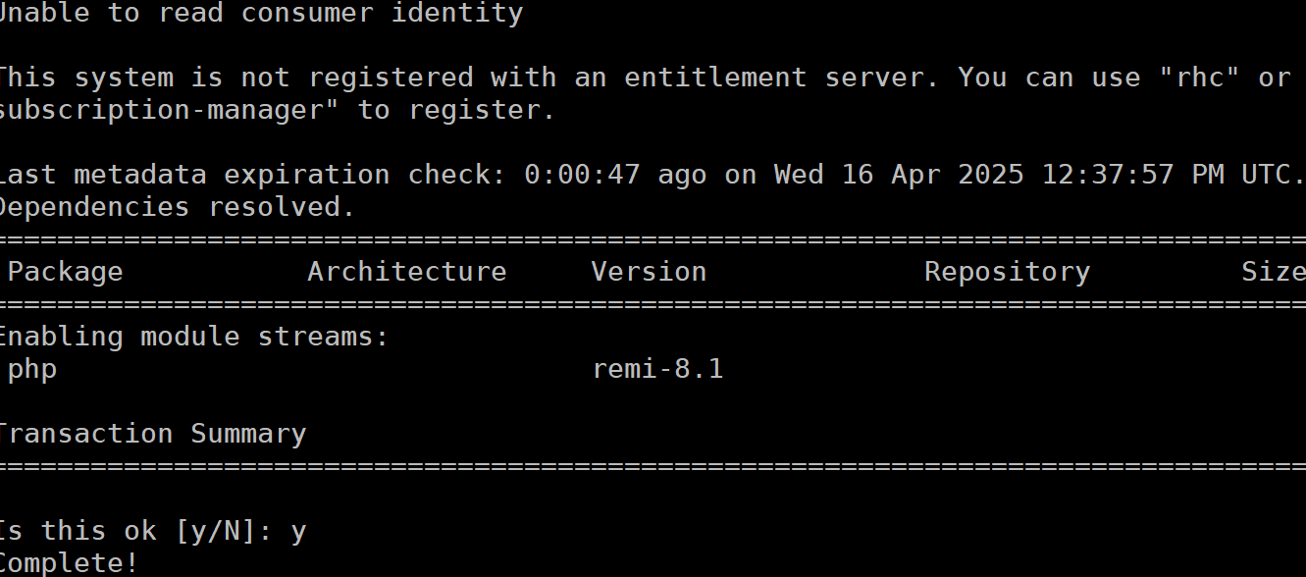

dnf install -y php php-mysqlnd php-fpm php-opcache php-gd php-curl php-mbstring php-xml php-json php-cli

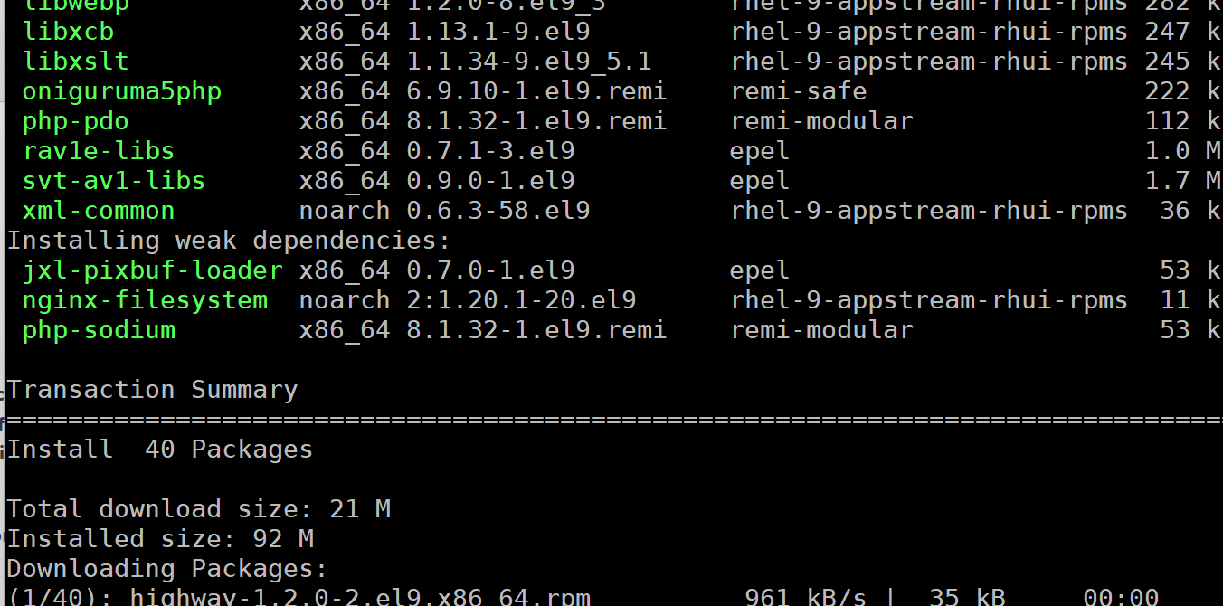
systemctl restart httpd

- Download and Install WordPress
WordPress is the most used content management system in the world. A lot of websites that you visit everyday use WordPress. It is highly customizable and has a very healthy ecosystem of plugins that add or change functionality, and themes that change the appearance.
- Download WordPress to the web server folder on your system using the wget command and the zipped installation from the WordPress website. Unzip WordPress into the folder. Document your commands below.
cd /var/www/html
rm -f index.html info.php
wget https://wordpress.org/latest.tar.gz
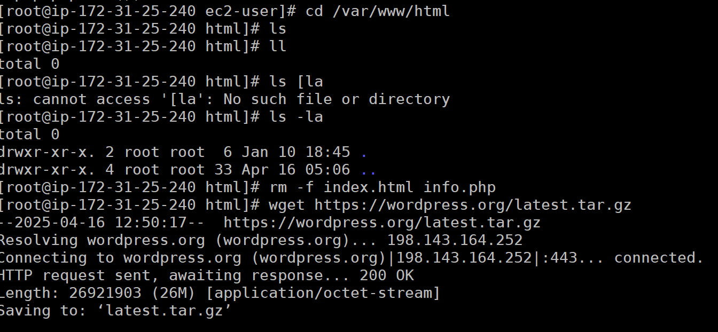

tar -xzf latest.tar.gz
cp -r wordpress/* /var/www/html/
rm -rf wordpress latest.tar.gz
ls -la
systemctl restart httpd

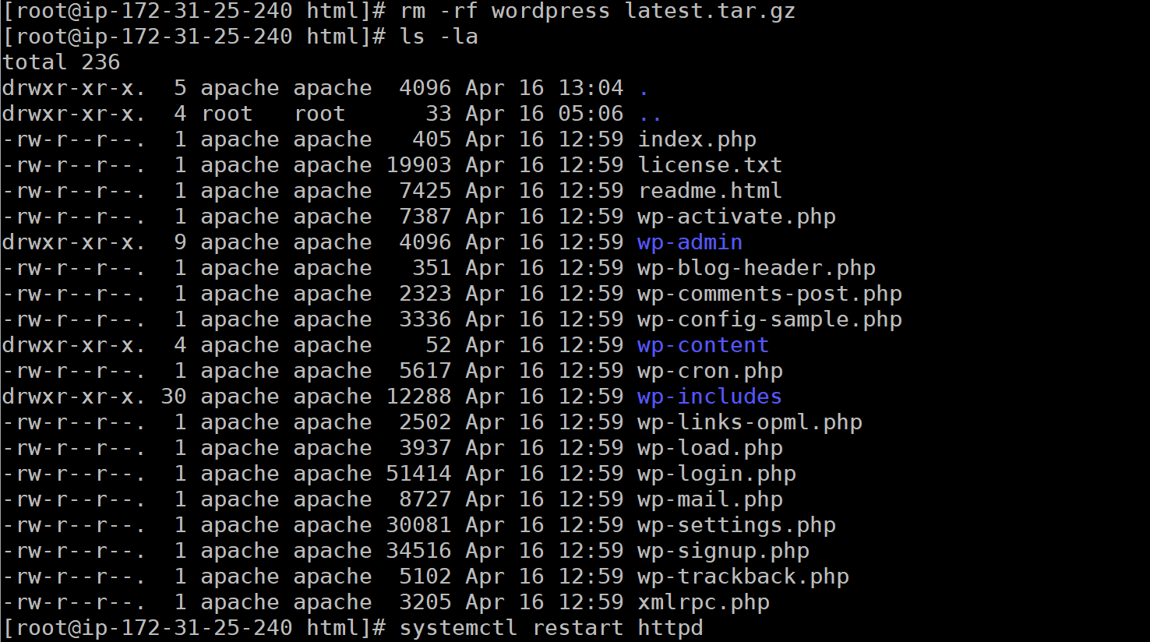
dnf install vim
vim wp-config.php
change the define info to match the information I gave
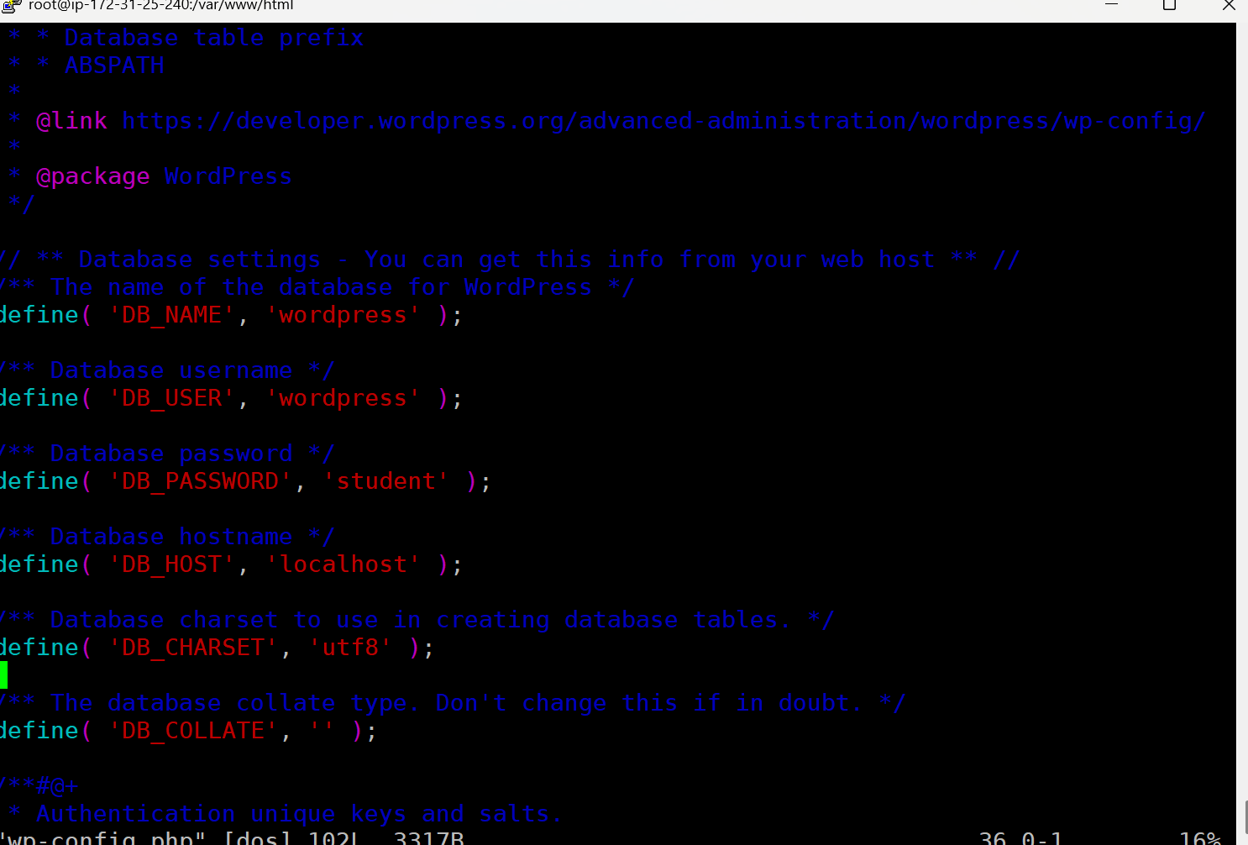
systemctl restart httpd
- Browse to your AWS Public DNS Address and you should be presented with the WordPress setup wizard. Fill in the database, username, and password we created before. Create a user and password to access the WordPress administration site. Document that information:
Username: | wordpress
Password: | student
- Login to WordPress and attach a screenshot of the administrative interface here:
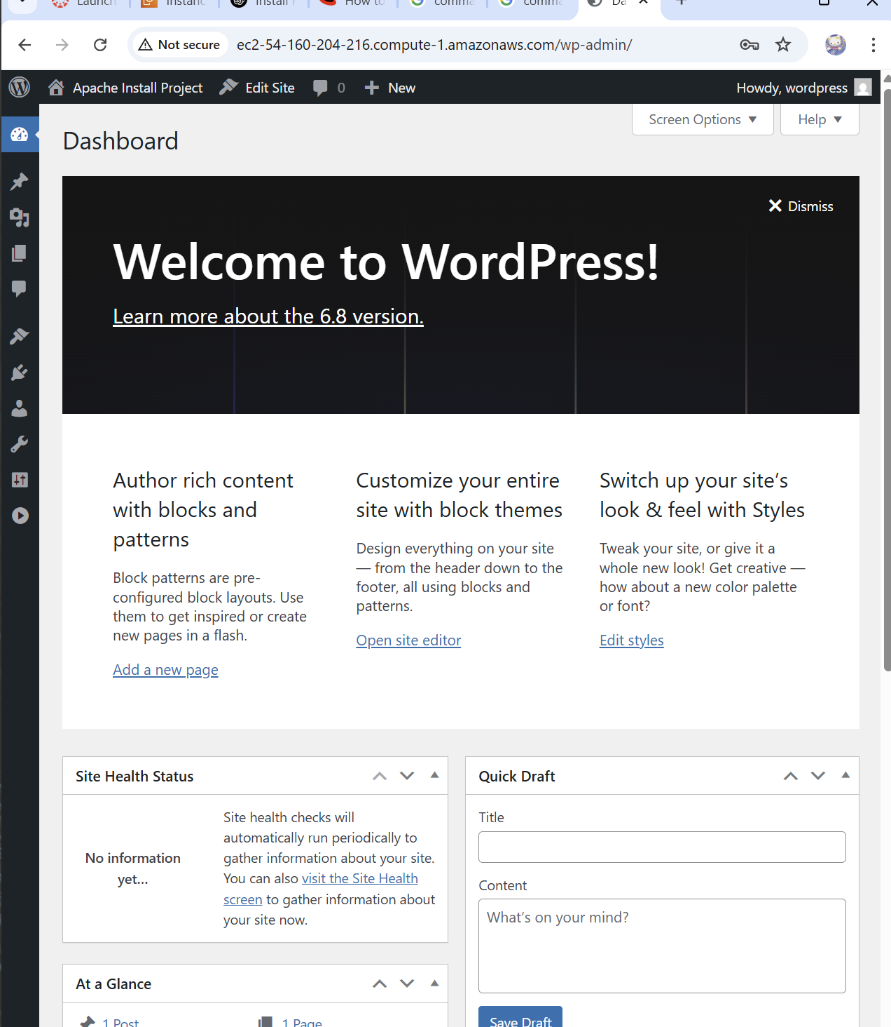
- Reflection
The steps that you just completed are very useful in the web hosting and Linux administration world. You can now spin up a cloud instance of Linux and install a basic server and run your own website on the internet! This can be done for very little money, without paying a hosting company for all the backend setup.
What did you find the most challenging? What did you find the most straightforward? Tell me about your overall experience.
To be honest, I approached this project with the knowledge of a previous class that I took, thinking that I would have a bit of an advantage, but I was wrong. In my previous class the system we were using was nginx and the application was applied with docker, so it took me a bit of research to get this wordpress site working without docker. I struggled with choosing the right version of php and wordpress to use, it took me a bit to figure out the right commands that would work. Thankfully, I found a command that used the latest version of wordpress and it worked. I want to say that I also struggled with some syntax errors when I was configuring the MySQL database on the server It was a minor issue but it can be frustrating. The most frustrating thing was the php installation, I more or less figured out that my issue was self-inflicted. I really overthought the solution to the point of frustration but when I stepped aside and took a break, I was able to find the solution.

In contrast the most straightforward aspect of this installation was also the one I struggled with the most. The wordpress installation was challenging but when I finally figured out the issue I had it was easier to complete that portion of the assignment. Another straightforward aspect of the project was the vim editing. Once I figured out that that was another issue I faced, editing the components that needed to be changed to allow the wordpress site to run the installation was (in hindsight) obvious.

Overall, I must say that once I got passed the frustrating troubleshooting I was excited to see the result of my efforts come to fruition. I was so satisfying to solve the problems I faced one by one till I got the result I needed.

